**UNIT Testing**

**Spark Job Testing:**

**Airflow Job Testing:**

AppConfig file not found:

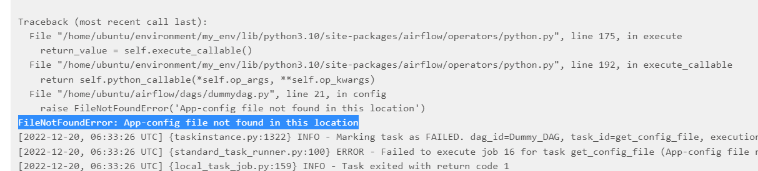

Datasets not found in the landing zone:

File not found in the Raw zone:

